Alec Barker

Chapter 9 Project – 9.3.5

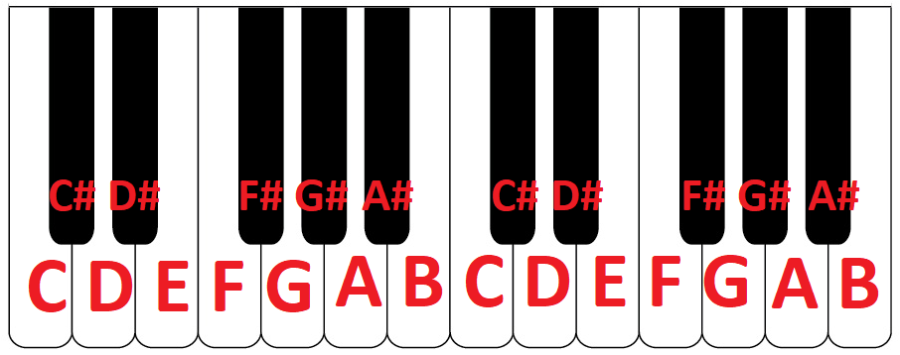
A standard keyboard could be used as a MIDI device to replicate a guitar. It would be a bit more difficult since the player couldn’t easily mimic strumming across the strings, but it could be done by quickly playing the notes one at a time or just playing all notes together and ignoring the sound of the individual strings while strumming. Just like a normal keyboard, each key would correlate to a note/octave pair. The main difficulty would be complex multi-string chords since they might be located all across the keyboard. Maybe it would make sense to have something like two short keyboards, one above the other. As the key is played on the keyboard, the note would recorded by the MIDI device and could either be played as the player hits the note or stored for later use. The Python program would use the MidiIn.onNoteOn function to start playing the note or would record the note for later. On MidiIn.onNoteOff, it would stop playing the note or record the length that the note was played and store it for later. To make it a guitar, the MIDI play device could just be set to GUITAR in the Python code. This instrument could be used for live MIDI performances or for creating a song that can possibly be edited later. Someone would have to be familiar with how to play a keyboard to play this, and they would probably need to know how to read sheet music to transcribe notes from guitar to piano keys.
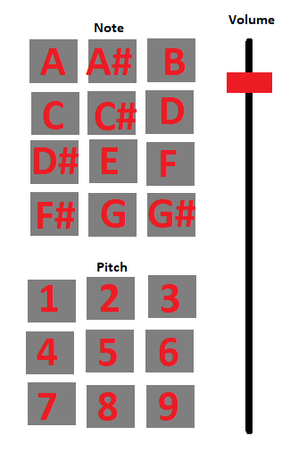
- This GUI would be shown on a phone screen and work via OSC messages to the Python receiver. The idea is that the user could tap a pitch to set it for all the notes they are about to play. They could then tap the notes. They could also set the volume with a slider. As an example, a user might tap the “5” button, then tap the “A”, “G”, and “C#” buttons. This would make the program play A5, G5, and C#5. As with the instrument above, it could be used for live playing or for recording pitches and durations. I feel like this instrument would require a lower skill level since most people could easily figure out how it works since it is just two sets of buttons and they would be labeled. Since the MIDI sounds could be played on the phone as well as on the receiver computer, people could play around and experiment with notes. I think it would moreso be for hobbyists rather than serious musicians.
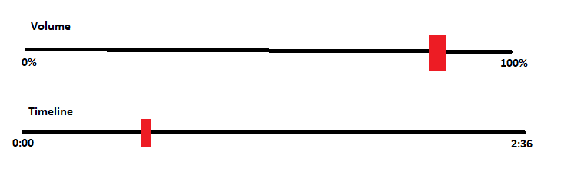
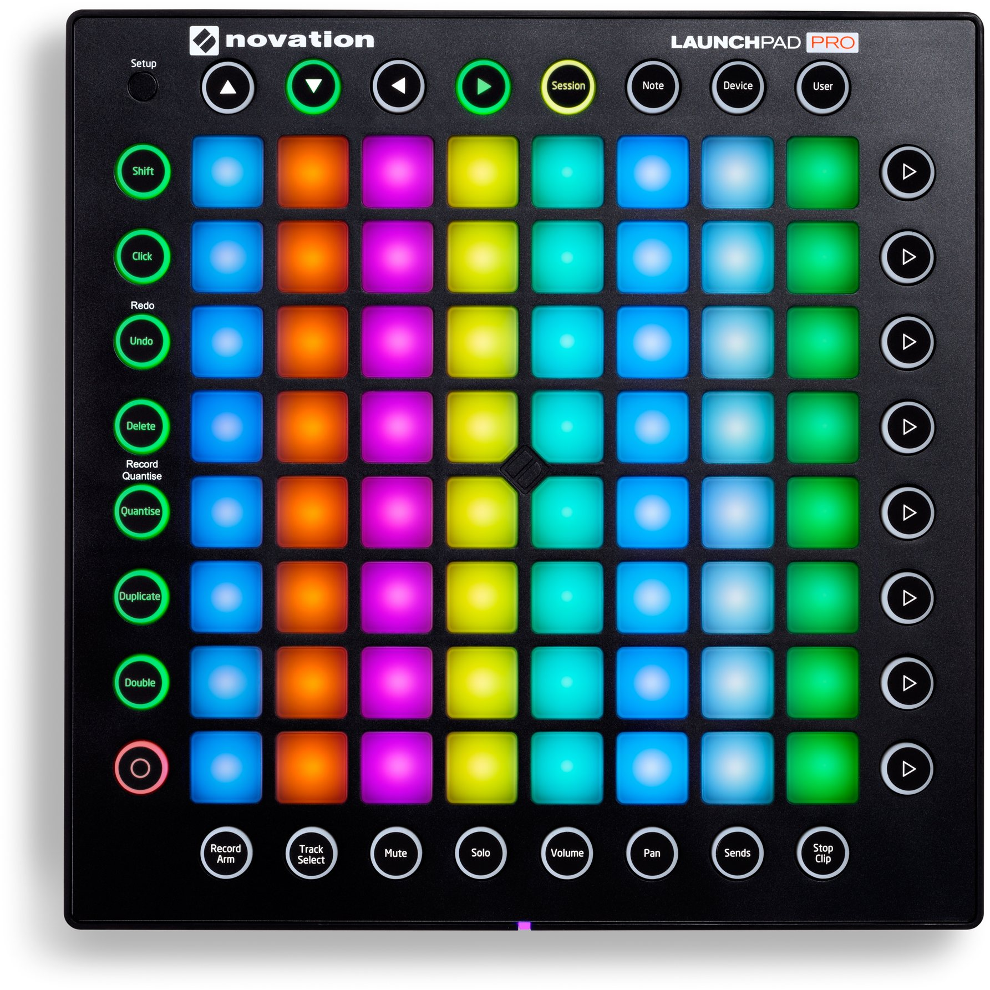
- This instrument would be a combo of a music pad for doing note inputs and a phone with sliders to control things like volume or a timeline (if the user is recording the input rather than just playing it live). The music pad could be mapped to any notes the user wants, so it is pretty customizable. Using the combo of the music pad and phone would probably save the user some money since they wouldn’t need to pay for a more complicated music pad with more controls. The user that would probably use this the most would be someone like a DJ or amateur musician who doesn’t have the instruments to record their own songs. I think they might have to know a bit more about music so they know which notes they need to map out, but they could just play around with it. This could be something to just practice music or play some songs without large instruments.
- The link to my demonstration of part 4 is here: https://youtu.be/d-m6Hfd1i68
I built a prototype of the instrument I mentioned in part 2. I used the "OSC Controller" app by Adam Katz found on the Google Play Store for this since it had a few of the features I mentioned. In the video, the code on my desktop is displayed on the left, and a recording of my phone screen is on the right.
- I think that the use of smartphones and OSC to make music has quite a bit of potential for people to make music anywhere they would like as long as they are connected to an internet connection. Many people could connect wirelessly to the receiver and all work on a song together with only their phones. The people who know how to play an instrument could play one with a MIDI device and less experienced players could use their phones. Nobody would be left out.

